Topic:DOCKER

SUBMIT via SCREENSHOTS

1. Create your image with dockerfile.

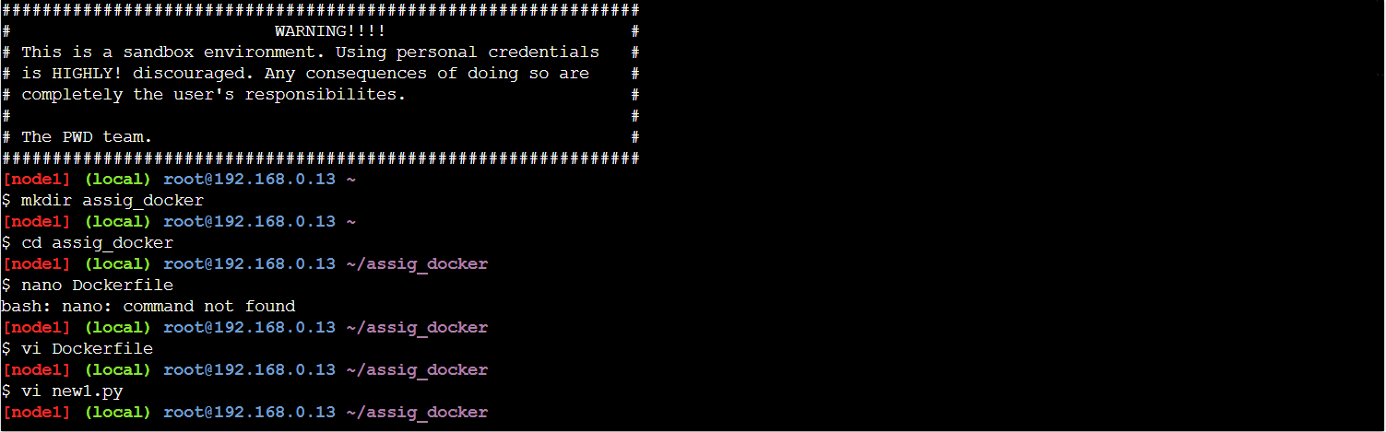

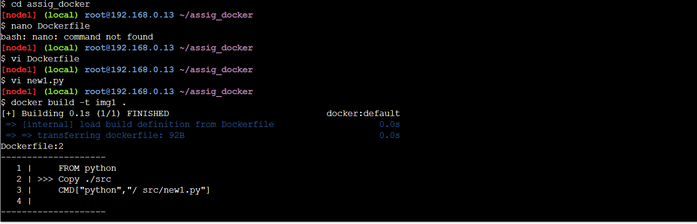

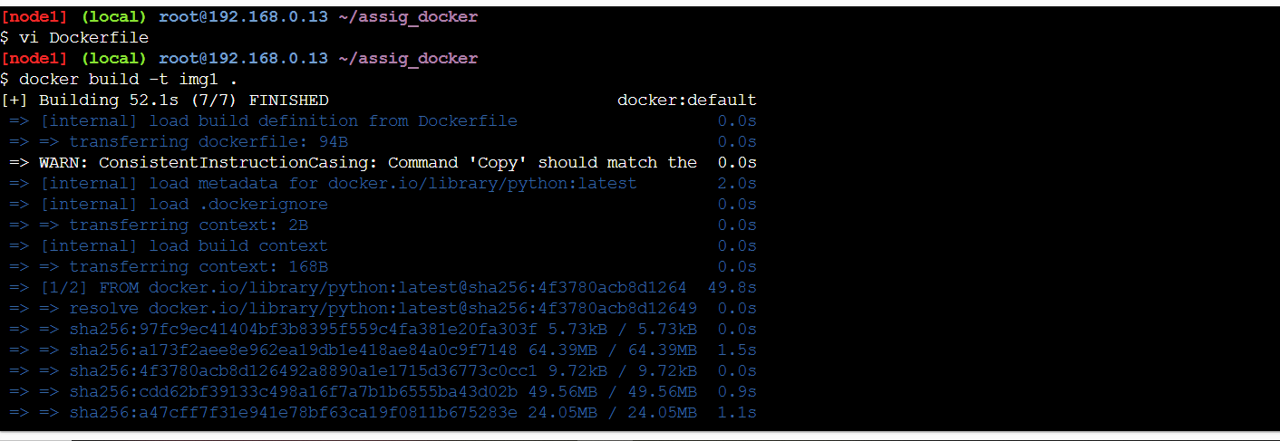

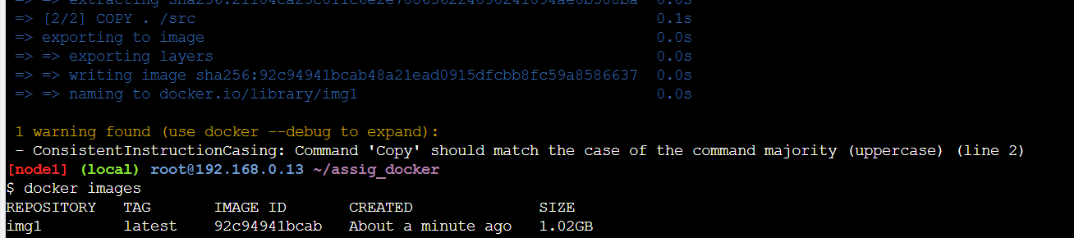

1. Build and deploy your application in the Docker.

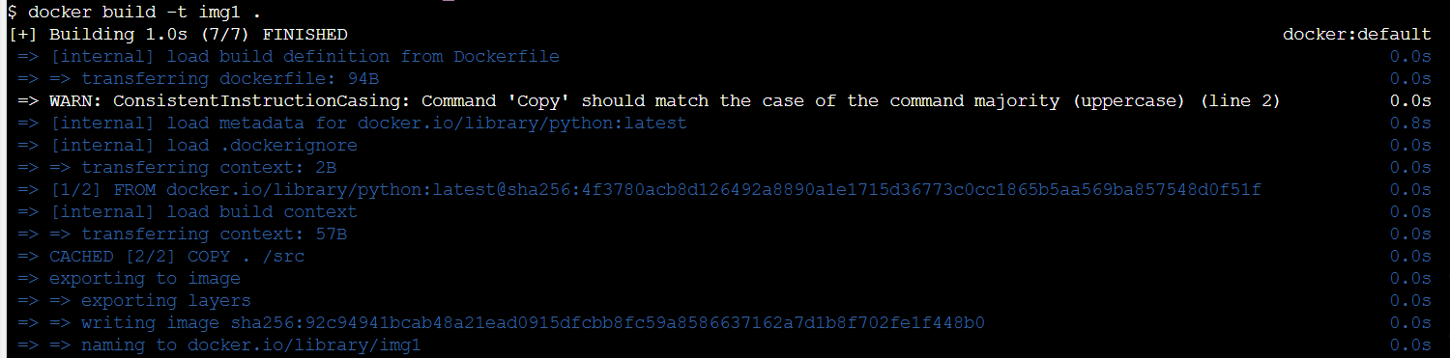

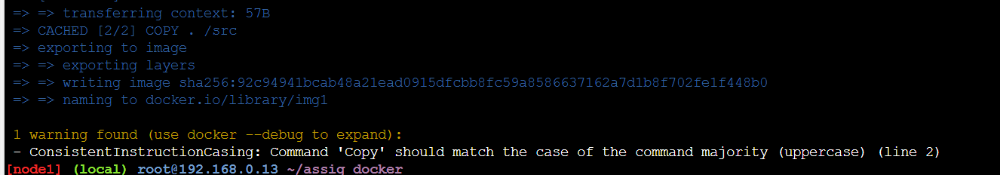

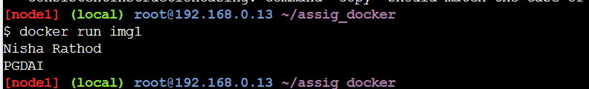

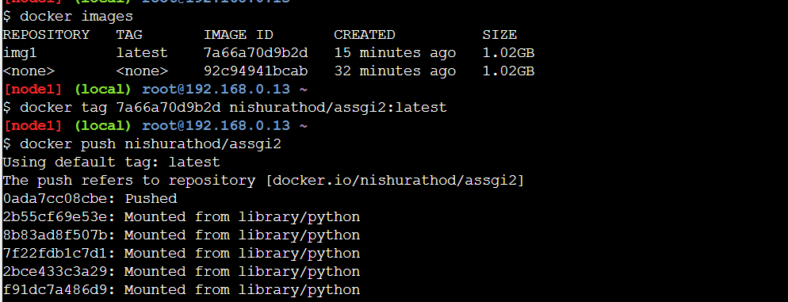

1. Push your image into Docker hub as public repository.

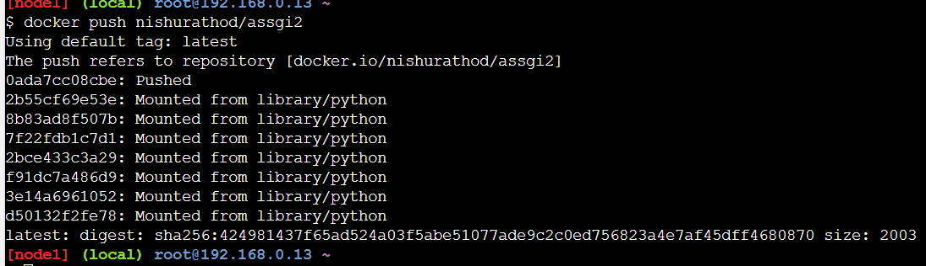

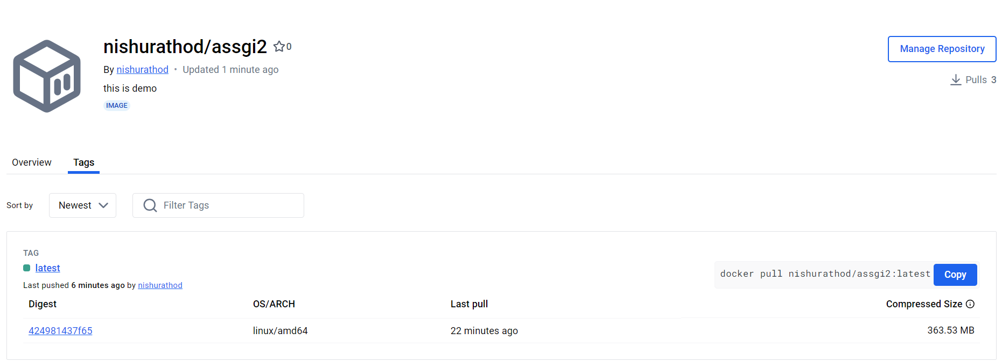

1. Run the commands on Docker terminal

